Project Planning Phase
Project Planning Template (Product Backlog, Sprint Planning, Stories, Story points)

Date | 02 July 2026
Team ID
Project Name | Heritage Treasures: An In-Depth Analysis of UNESCO World Heritage Sites in Tableau
Maximum Marks | 5 Marks

Product Backlog, Sprint Schedule, and Estimation (4 Marks)
Use the below template to create product backlog and sprint schedule
Sprint | Functional Requirement (Epic) | User Story Number | User Story / Task | Story Points | Priority | Team Members
Sprint-1 | Data Collection | USN-1 | Collect UNESCO World Heritage Sites dataset from official/public sources. | 2 | High | Team
Sprint-1 |  | USN-2 | Load the dataset into Tableau Desktop for analysis. | 1 | High | Team
Sprint-1 | Data Preparation | USN-3 | Handle missing values and clean inconsistent records. | 3 | High | Team
Sprint-1 |  | USN-4 | Create calculated fields and prepare data for visualization. | 3 | Medium | Team
Sprint-1 |  | USN-5 | Standard and validate heritage data for accurate analysis. | 3 | High | Team
Sprint-2 | Data Visualization | USN-6 | Develop Bar chart visualization. | 2 | Medium | Team
Sprint-2 |  | USN-7 | Develop Pie chart visualization. | 2 | Medium | Team
Sprint-2 |  | USN-8 | Develop Line chart visualization. | 2 | Medium | Team
Sprint-2 |  | USN-9 | Develop Interactive Map visualization. | 4 | High | Team
Sprint-2 | Dashboard Development | USN-10 | Create an interactive Tableau Dashboard. | 5 | High | Team
Sprint-2 | Story Development | USN-11 | Develop Tableau Story with interactive story points. | 5 | High | Team

Project Tracker, Velocity & Burndown Chart: (4 Marks)
Sprint | Total Story Points | Duration | Sprint Start Date | Sprint End Date (Planned) | Story Points Completed (as on Planned End Date) | Sprint Release Date (Actual)
Sprint-1 | 12 | 6 Days | 24 Jun 2026 | 30 Jun 2026 | 12 | 30 Jun 2026
Sprint-2 | 20 | 6 Days | 30 Jun 2026 | 05 Jul 2026 | 20 | 05 Jul 2026

Velocity:
Imagine we have a 6-day sprint duration, and the velocity of the team is 16 (points per sprint). Let’s calculate the team’s average velocity (AV) per iteration unit (story points per day)
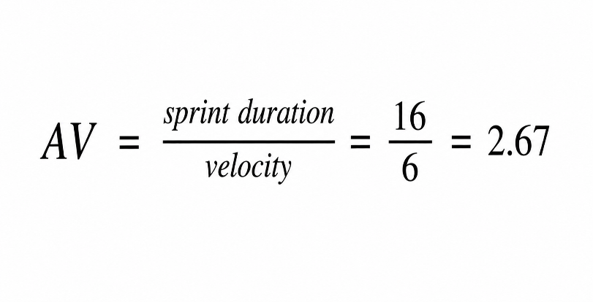

Burndown Chart:
A burn down chart is a graphical representation of work left to do versus time. It is often used in agile software development methodologies such as Scrum. However, burn down charts can be applied to any project containing measurable progress over time.

https://www.visual-paradigm.com/scrum/scrum-burndown-chart/
https://www.atlassian.com/agile/tutorials/burndown-charts

Reference:
https://www.atlassian.com/agile/project-management
https://www.atlassian.com/agile/tutorials/how-to-do-scrum-with-jira-software
https://www.atlassian.com/agile/tutorials/epics
https://www.atlassian.com/agile/tutorials/sprints
https://www.atlassian.com/agile/project-management/estimation
https://www.atlassian.com/agile/tutorials/burndown-charts

